# CGRA 352 – Assignment 4

300446258

Jackson Tume

*-Brief introduction of your functions in your programs.*

All the functions are in the main.cpp file. It first loads all the light field images, and access the 4d point (7, 10, 384, 768) and should output [99, 135, 219] to the console. The program then generates the ST-array, it does not display the results of the ST-array in a window as it’s a large image. But the results of all the ST-array’s (no aperture, 75 and 40 radius) can be found in the output folder attached with the submission. The program then a new image with a virtual focal length, it’s currently setup with the default focal length of 1 but the different focal length results are also found in the output folder. There is a bug with my focal stack part, where the bottom has weird black lines at some focal lengths.

*-How to run your program to perform the functions required by the assignment.*

The program will automatically run all the functions required by the assignment. The only requirement is the path to the rectified as an argument (the folder is not attached with the submission as its 100mb and I don’t wanna destroy the ecs servers).

*-The results of ST-array. Aperture centred at (-776.880371, 533.057190)*

*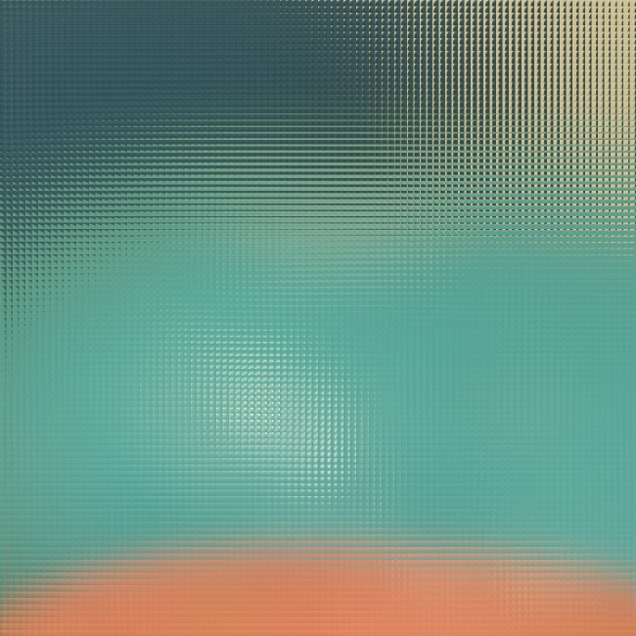Left-(No Aperture), Right-(75 Aperture), Bottom(40 Aperture)*

*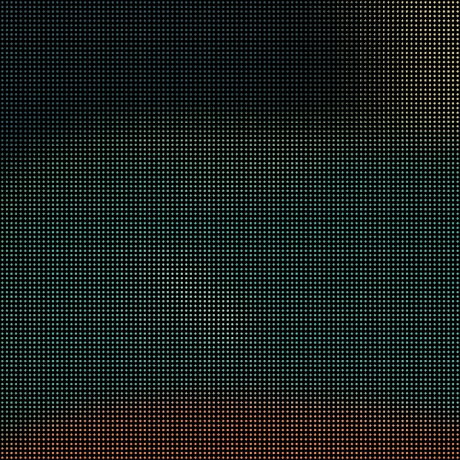 *In the output folder in submission, is the high res images*

*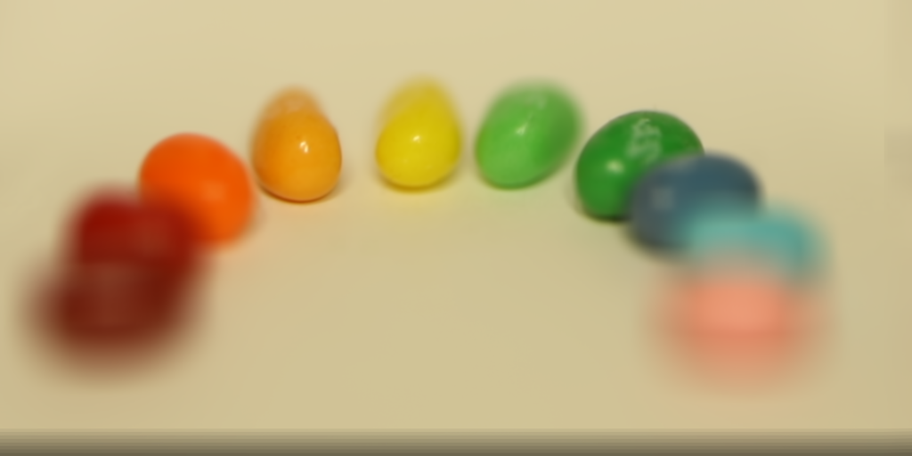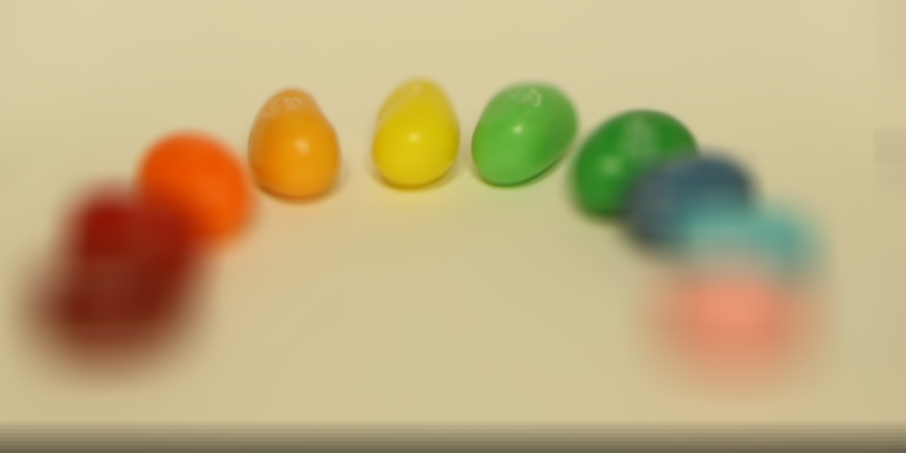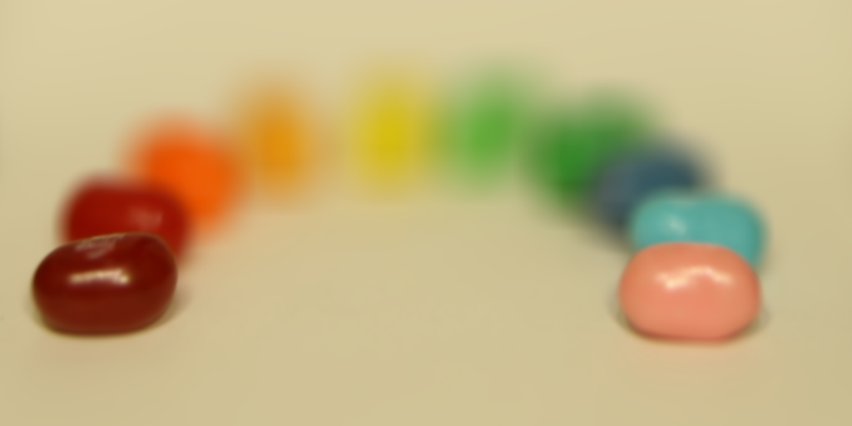-The results of different focal lengths*

